Updated 3/26/20 @ 8:00 am
Resources for Completing Diversity Passport Credits
(Designed to be Completed Remotely)
This is a living and collaborative document. Please send me any suggestions for web activities, books, films or podcasts that you think would be useful in meeting the goals of the Diversity Passport. Libby rhoadese1@southernct.edu

Activity | Where to Find It
Academic Language and English Language Learners (Reading Rockets Webinar) | https://www.readingrockets.org/webcasts/3003
Assessment of English Language Learners (Reading Rockets Webinar) | https://www.readingrockets.org/webcasts/1003
The Autistic Brain (Presence Learning Webinar presented by Temple Grandin) | https://www.presencelearning.com/sped-ahead-webinar/templegrandin/
Best Practices for Serving English Language Learners and Their Families (49 minute Teaching Tolerance Webinar) | https://event.on24.com/eventRegistration/EventLobbyServlet?target=reg20.jsp&partnerref=rss-events&eventid=1582343&sessionid=1&key=D3A7BA10CB60762B11E128D285136FCC&regTag=&sourcepage=register
Best Practices in Screening and Assessment of Refugee Youth (60 minute NCTSN Webinar, 7ou will have to register for a free account) | https://learn.nctsn.org/course/view.php?id=371
Celebrating World Refugee Day: Understanding Refugee Experiences and Improving Services (60 minute NCTSN Webinar, you will have to register for a free account) | https://learn.nctsn.org/course/view.php?id=467
The Color of Law (67 minute Teaching Tolerance Webinar) | https://event.on24.com/eventRegistration/EventLobbyServlet?target=reg20.jsp&partnerref=rss-events&eventid=2110189&sessionid=1&key=4B58EA67ACB875E2E379330FACB7A161&regTag=&sourcepage=register
Cultura, experiencia migratoria, trauma, y evaluación (90 minute NCTSN Webinar in Spanish, you will have to register for a free account) | https://learn.nctsn.org/course/view.php?id=504
Cultural and Contextual Considerations in the Treatment of Childhood Traumatic Grief (90 minute NCTSN Webinar, you will have to register for a free account) | https://learn.nctsn.org/course/view.php?id=150
Darles Voz a Los Niños Inmigrantes: Entender la Separación Traumática (90 minute NCTSN Webinar in Spanish, you will have to register for a free account) | https://learn.nctsn.org/course/view.php?id=488
Dispelling Misconceptions About English Language Learners: Research-Based Ways to Improve Instruction (ASCD Webinar) | http://www.ascd.org/professional-development/webinars/dispelling-misconceptions-about-ells-webinar.aspx
Diversity, Equity, and Inclusion in All Classrooms (60 minute edWeb Webinar) | https://home.edweb.net/webinar/clrt20190911/
English Language Learners with Learning Disabilities (Reading Rockets Webinar) | https://www.readingrockets.org/webcasts/2007
Equity Matters: Confronting Implicit Bias Equity Matters: Understanding Equity Literacy (47 minute Teaching Tolerance Webinar | https://event.on24.com/eventRegistration/EventLobbyServlet?target=reg20.jsp&partnerref=rss-events&eventid=1327846&sessionid=1&key=B85C45F592AD530892C1B18D114B30BC&regTag=&sourcepage=register
Equity Matters: Developing Empathy (47 minute Teaching Tolerance Webinar | https://event.on24.com/eventRegistration/EventLobbyServlet?target=reg20.jsp&partnerref=rss-events&eventid=1327839&sessionid=1&key=D5371E11C03830C120DC56C1A73C385A&regTag=&sourcepage=register
Equity Matters: Understanding Equity Literacy (55 minute Teaching Tolerance Webinar | https://event.on24.com/eventRegistration/EventLobbyServlet?target=reg20.jsp&partnerref=rss-events&eventid=1327848&sessionid=1&key=FC5D5F667A60F66801020C2F291E28E8&regTag=&sourcepage=register
Extreme Prejudice (60 minute Teaching Tolerance Webinar) | https://event.on24.com/eventRegistration/EventLobbyServlet?target=reg20.jsp&partnerref=rss-events&eventid=1165869&sessionid=1&key=72622B45B5403FFFE4E02B2E087A2297&regTag=&sourcepage=register
Fulfilling the Promise of Brown: School Discipline, Education Equity and the Achievement Gap (ADL Webinar) | https://www.adl.org/education/resources/webinars/fulfilling-the-promise-of-brown-school-discipline-education-equity
Gender Savvy: Creating an Inclusive School Climate (62 minute Teaching Tolerance Webinar) | https://event.on24.com/eventRegistration/EventLobbyServlet?target=reg20.jsp&partnerref=rss-events&eventid=1114116&sessionid=1&key=5E929E2A23CDB9614FE2205457967D17&regTag=&sourcepage=register
Giving Immigrant Children a Voice: Understanding Traumatic Separation (90 minute NCTSN Webinar, you will have to register for a free account) | https://learn.nctsn.org/course/view.php?id=486
How to Become the Educator That Male Black and Latino Students Need (ASCD Webinar) | http://www.ascd.org/professional-development/webinars/educating-black-and-latino-males-webinar.aspx
I Cannot Be Me: What Transgender and Gender Nonconforming Youth Tell Us About their School Experiences (60 minute GLSEN webinar) | https://vimeo.com/302918119
Immigration and Trauma: Clinical Observations of Four Immigrant Psychotherapists Working With Latino Immigrant Families (90 minute NCTSN Webinar, you will have to register for a free account) | https://learn.nctsn.org/course/view.php?id=346
Inclusion Is for Every Learner — Or is It? (Presence Learning Webinar) | https://www.presencelearning.com/sped-ahead-webinar/inclusion-is-for-every-learner-or-is-it/
Indigenous Peoples' History (86 minute Teaching Tolerance Webinar) | https://event.on24.com/eventRegistration/EventLobbyServlet?target=reg20.jsp&partnerref=rss-events&eventid=2110188&sessionid=1&key=274AAFA9DB7EAD97E46D847636FFDE1F&regTag=&sourcepage=register
Intersectionality (58 minute Teaching Tolerance Webinar) | https://event.on24.com/eventRegistration/EventLobbyServlet?target=reg20.jsp&partnerref=rss-events&eventid=1185099&sessionid=1&key=10D5C7F09450CE97BC59E84A68224791&regTag=&sourcepage=register
Intervenciones con niños muy pequeños, informadas en apego, desarrollo, trauma y cultura (90 minute NCTSN Webinar in Spanish, you will have to register for a free account) | https://learn.nctsn.org/course/view.php?id=517
Intervenciones sensibles a la cultura, el desarrollo y el trauma con jóvenes de 7 años y mayores​​ (90 minute NCTSN Webinar in Spanish, you will have to register for a free account) | https://learn.nctsn.org/course/view.php?id=510
Introducing Students to Difficult Topics: Primary Sources and Picture Books Webinar (ADL webinar) | https://www.adl.org/education/resources/webinars/introducing-students-to-difficult-topics-primary-sources-and-picture
KABC-2 Normative Update Webinar (Pearson Webinar) | https://www.pearsonassessments.com/professional-assessments/blog-webinars/webinars/2019/09/kabc-2-normative-update.html
Key Steps for Implementing a Schoolwide Approach That Supports K–8 Emergent Bilingual Students (ASCD Webinar) | http://www.ascd.org/professional-development/webinars/emergent-bilingual-students-webinar.aspx
Latinx History Is Black History (62 minute Teaching Tolerance Webinar) | https://event.on24.com/eventRegistration/EventLobbyServlet?target=reg20.jsp&partnerref=rss-events&eventid=1931558&sessionid=1&key=15CCB2C1B80A28B051D4350FA511907E&regTag=&sourcepage=register
Let's Talk! Discussing Gender in the Classroom (51 minute Teaching Tolerance Webinar) | https://event.on24.com/eventRegistration/EventLobbyServlet?target=reg20.jsp&partnerref=rss-events&eventid=1255656&sessionid=1&key=3F12628B6060E2D4BC0596BCC1291E81&regTag=&sourcepage=register
Let's Talk! Discussing Whiteness (47 minute Teaching Tolerance Webinar) | https://event.on24.com/eventRegistration/EventLobbyServlet?target=reg20.jsp&partnerref=rss-events&eventid=1255663&sessionid=1&key=C536E81F36CB313B3F30F0B3704D3650&regTag=&sourcepage=register
Religious Freedom and LGBT Equality (62 minute Teaching Tolerance Webinar) | https://event.on24.com/eventRegistration/EventLobbyServlet?target=reg20.jsp&partnerref=rss-events&eventid=1185109&sessionid=1&key=5AF22CF060470F5F1141FEA22F877578&regTag=&sourcepage=register
Let's Talk! Teaching Black Lives Matter (56 minute Teaching Tolerance Webinar) | https://event.on24.com/eventRegistration/EventLobbyServlet?target=reg20.jsp&partnerref=rss-events&eventid=1327843&sessionid=1&key=71656A4E5CD94975E4E961E4A8A9643F&regTag=&sourcepage=register
LGBTQ Best Practices: Classroom Culture and Curriculum (46 minute Teaching Tolerance Webinar) | https://event.on24.com/eventRegistration/EventLobbyServlet?target=reg20.jsp&partnerref=rss-events&eventid=1844968&sessionid=1&key=FEC447F8E9C44B4DA6C3FA11EDB57086&regTag=&sourcepage=register
NASP Graduate Student Webinars at https://www.nasponline.org/resources-and-publications/graduate-students/graduate-student-webinars

- Developing Strong Social Justice Habits and Practices as a Graduate Student
- Cultivating Understanding Across Great Divides: Engaging in Equity Dialogue
- Legislative and Social Justice Advocacy in School Psychology
NASP Podcasts at https://apps.nasponline.org/resources-and-publications/podcasts/index.aspx

- Working with Forcibly Displaced Children and Families for Long-Term Success
- NASP Distinguished Lecture: Belonging, Identity, and Behavior—Engaging the Potential of Diverse Student Learners
- Beyond the Rainbow: School-Based Mental Health Supports for LGBTQ+ Youth
- Disproportionality in Discipline
- Encountering and Overcoming Resistance to Social Justice in Practice
- Creating Safe Spaces for LGBTQ+ Students in Schools
- School-to-Prison Pipeline
- Beyond the Rainbow: School-Based Mental Health Supports for LGBTQ+ Youth
- Punitive to Positive: Building Relationships Through Restorative Practices
- Understanding Gangs from The Street Perspective
- Social Justice Perspective on Bullying Prevention
- Understanding White Privilege
- Best Practices for Supporting Refugee Students and Their Families
- Discussing and Addressing Privilege and Poverty in Schools
- School Psychology Review (SPR) Insights: Closing the Racial Discipline Gap in Classrooms by Changing Teacher Practice
- NASP Dialogues: Students Learning English as a Second Language
- NASP Dialogues: Helping Transgender Students Succeed at School and at Home
- Training ELL Parents to Promote Social-Emotional Resiliency from Home
- Through a New Lens: Transforming EBD Identification Through Culturally Responsive Approaches
- Individual Counseling with LGBTQ Students: Ethical and Affirmative Practices
- What Psychologists Need to Know About Language: Assessment, Instructional, and Cultural Perspectives
- Promoting the Educational Success of Refugee Newcomer Students and Families
- NASP Dialogues: Homelessness
- Confronting Inequity in Special Education, Part I: Understanding the Problem of Disproportionality
- Confronting Inequity in Special Education, Part II: Promising Practices in Addressing Disproportionality
- NASP Dialogues: Effective Communication with Black Families and Students
- NASP Dialogues: Indigenous Americans
- NASP Dialogues: Interview with Janine Jones, Editor of The Psychology of Multiculturalism in the Schools: A Primer for Practice, Training, and Research
- Keynote Address: New Perspective On Aggression in Boys and Girls
- NASP Dialogues: Homophobia and Bullying Roundtable

National School Climate Survey (NSCS) Research (GLSEN Webinar on LGBTQ student experiences in K-12 schools ) | https://vimeo.com/296088897
Reading to Learn: ELLs in Grades 4-6 (Reading Rockets Webinar) | https://www.readingrockets.org/webcasts/2004
Religious Diversity in the Classroom Fostering a Culture of Respect (61minute Teaching Tolerance Webinar) | https://www.tolerance.org/professional-development/webinars/religious-diversity-in-the-classroom-fostering-a-culture-of
Responding to Hate and Bias at School (60 minute Teaching Tolerance Webinar) | https://event.on24.com/eventRegistration/EventLobbyServlet?target=reg20.jsp&partnerref=rss-events&eventid=1500088&sessionid=1&key=67A2FF04489AB2475A8D244714D99634&regTag=&sourcepage=register
Responding to LGBTQ Youth after Sexual Abuse (90 minute NCTSN Webinar, you will have to register for a free account) | https://learn.nctsn.org/course/view.php?id=137
Speak Up at School (54 minute Teaching Tolerance Webinar) | https://event.on24.com/eventRegistration/EventLobbyServlet?target=reg20.jsp&partnerref=rss-events&eventid=1500168&sessionid=1&key=32AF13638BC4D404AE9AEE1589EE67B8&regTag=&sourcepage=register
Success with Multicultural Newcomers and English Learners (ASCD Webinar) | http://www.ascd.org/professional-development/webinars/success-with-multicultural-newcomers-webinar.aspx
Supporting Trans and Gender-Nonconforming Students with Pride (ASCD Webinar) | http://www.ascd.org/professional-development/webinars/supporting-trans-and-gender-nonconforming-students-with-pride-webinar.aspx
Using an Anti-Bias Lens to Examine Early Childhood Children’s Books (ADL Webinar) | https://www.earlychildhoodwebinars.com/webinars/using-an-anti-bias-lens/
What Is White Privilege, Really? (91 minute Teaching Tolerance Webinar) | https://event.on24.com/eventRegistration/EventLobbyServlet?target=reg20.jsp&partnerref=rss-events&eventid=1909522&sessionid=1&key=E07BFD130D442280B28A62312B565227&regTag=&sourcepage=register
When NO is Not Enough: Information on Teen Sexual Assault (90 minute NCTSN Webinar, you will have to register for a free account) | https://learn.nctsn.org/course/view.php?id=328
Your Students, My Students, Our Students: Rethinking Equitable and Inclusive Classrooms (ASCD Webinar) | http://www.ascd.org/professional-development/webinars/your-students-my-students-our-students-webinar.aspx
Youtube & Ted Talk Videos
ADHD and Tourette Syndrome. https://www.youtube.com/watch?v=MY2UiJSH7VUk

Historian Elizabeth Stordeur Pryor on Why It’s So Hard to Talk about the N-word. https://www.ted.com/talks/elizabeth_stordeur_pryor_why_it_s_so_hard_to_talk_about_the_n_word

Rebecca Knill on How Technology Has Changed What It’s Like to Be Deaf. https://www.ted.com/talks/rebecca_knill_how_technology_has_changed_what_it_s_like_to_be_deaf

Miriam Zoila Pérez on How Racism Harms Pregnant Women. https://www.ted.com/talks/miriam_zoila_perez_how_racism_harms_pregnant_women_and_what_can_help?referrer=playlist-talks_for_when_you_re_expectin

Nanfu Wang on What it was like to grow up under China's one-child policy. https://www.ted.com/talks/nanfu_wang_what_it_was_like_to_grow_up_under_china_s_one_child_policy

George Takei: Why I love a country that once betrayed me. https://www.ted.com/talks/george_takei_why_i_love_a_country_that_once_betrayed_me

Dena Simmons: How students of color confront impostor syndrome. https://www.ted.com/talks/dena_simmons_how_students_of_color_confront_impostor_syndrome

Books you can read and submit a brief summary and reflection for credit:
White Trash: The 400-Year Untold History of Class in America  By Nancy Isenberg  2016, Viking | 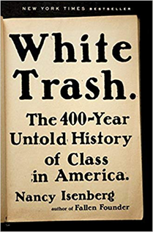 |  | Mama's Boy, Preacher's Son: A Memoir of Growing Up, Coming Out, and Changing America's Schools  By Kevin Jennings  2007, Beacon Press |  | 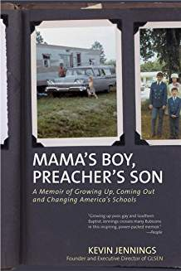
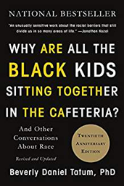 | Why Are All the Black Kids Sitting Together in the Cafeteria? And Other Conversations About Race  By Beverly Daniel Tatum  2017, Basic Books |  | 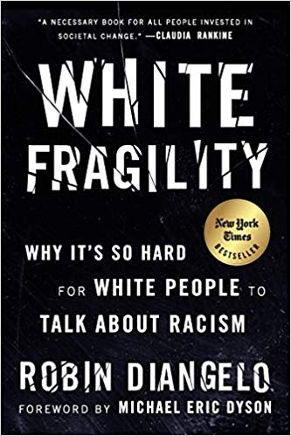 |  | White Fragility: Why It's So Hard for White People to Talk About Racism  By Robin DiAngelo  2018, Beacon Press
Waking Up White, and Finding Myself in the Story of Race  By Debby Irving  2014, Elephant Room Press | 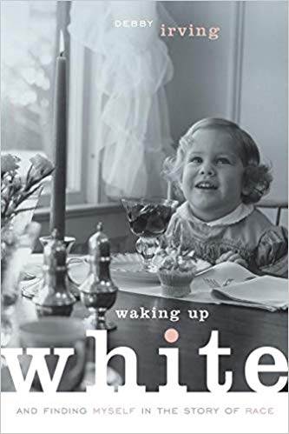 |  | Whistling Vivaldi: How Stereotypes Affect Us and What We Can Do  By Claude M. Steele  2011, W. W. Norton & Company |  | 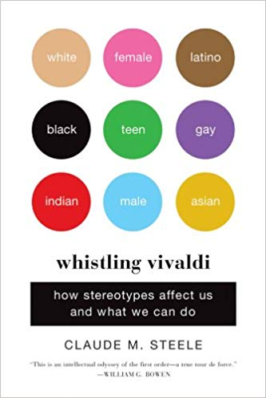
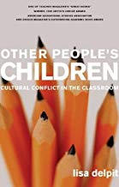 | Other People's Children: Cultural Conflict in the Classroom  By Lisa Delpit  2006, The New Press |  |  |  | Nickel and Dimed: On (Not) Getting By in America  By Barbara Ehrenreich  2011, Picador
Half and Half: Writers on Growing Up Biracial and Bicultural  By Claudine Chiawei O'Hearn  1998, Pantheon | 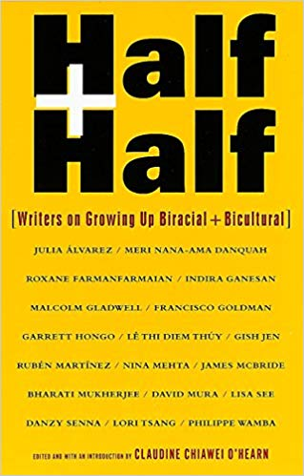 |  | Fading Scars: My Queer Disability History  By Corbett Joan OToole  2015, Autonomous Press |  | 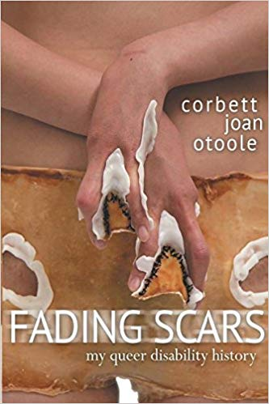
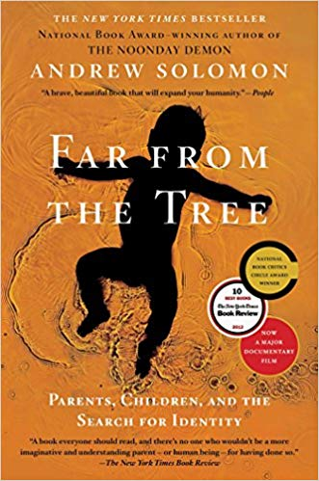 | Far from the Tree: Parents, Children and the Search for Identity  By Andrew Solomon  2013, Scribner |  | 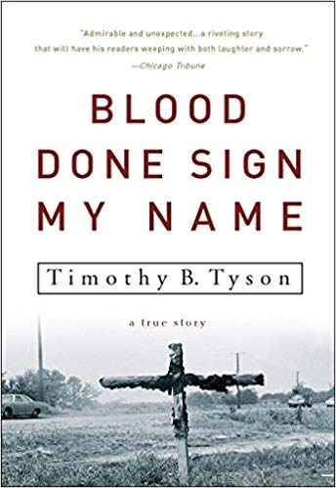 |  | Blood Done Sign My Name: A True Story  By Timothy B. Tyson  2005, Broadway Books
The Best of Enemies: Race and Redemption in the New South  By Osha Gray Davidson  1996, Scribner | 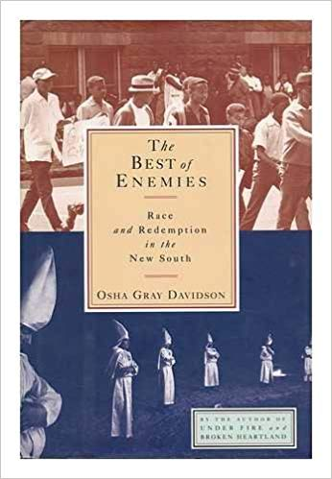 |  | Stony the Road: Reconstruction, White Supremacy, and the Rise of Jim Crow  By Henry Louis Gates Jr.  2019, Penguin Press |  | 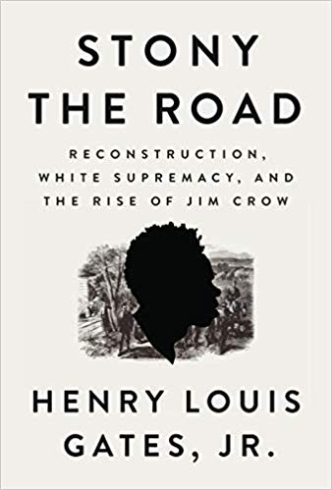
 | Water Tossing Boulders: How a Family of Chinese Immigrants Led the First Fight to Desegregate Schools in the Jim Crow South  By Adrienne Berard  2017, Beacon Press |  | 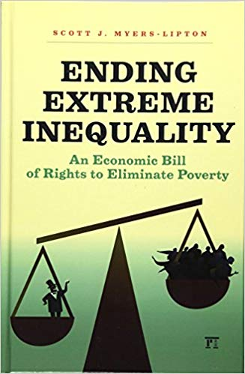 |  | Ending Extreme Inequality: An Economic Bill of Rights to Eliminate Poverty  By Scott Myers-Lipton  2014, Routledge
Missoula: Rape and the Justice System in a College Town  By Jon Krakauer  2015, Doubleday | 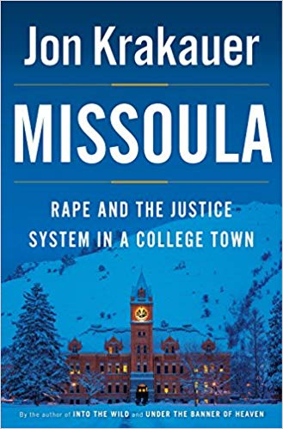 |  | Canaries Reflect on the Mine: Dropouts' Stories of Schooling  By Jeanne Cameron  2012, Information Age Publishing |  | 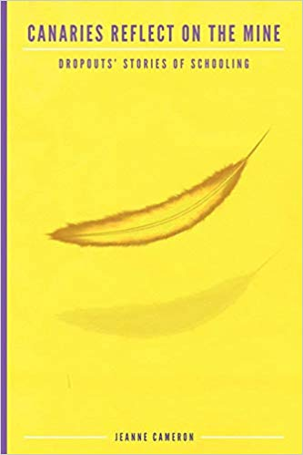
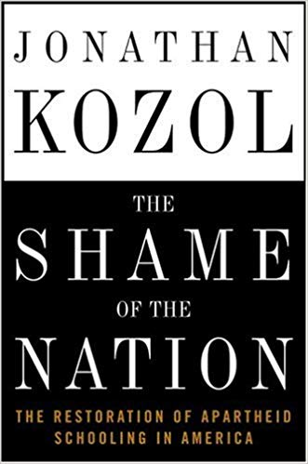 | The Shame of the Nation: The Restoration of Apartheid Schooling in America  By Jonathan Kozol  2005, Crown |  | 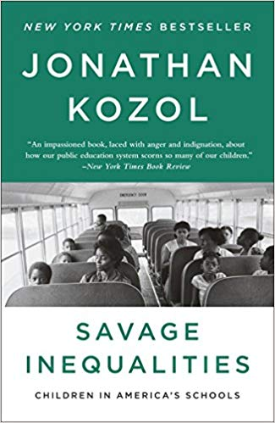 |  | Savage Inequalities: Children in America's Schools  By Jonathan Kozol  2012, Broadway Books
Ending Ageism, or How Not to Shoot Old People  By Margaret Morganroth Gullette  2017, Rutgers University Press | 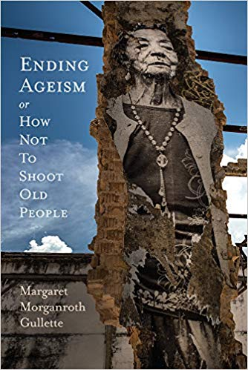 |  | Ahimsa  By Supriya Kelkar  2017, Tu Books |  | 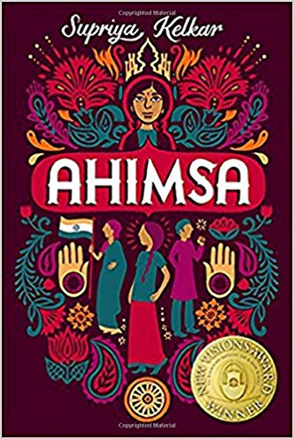
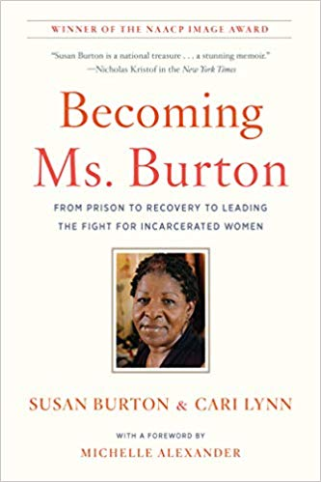 | Becoming Ms. Burton: From Prison to Recovery to Leading the Fight for Incarcerated Women  By Susan Burton  2017, The New Press |  | 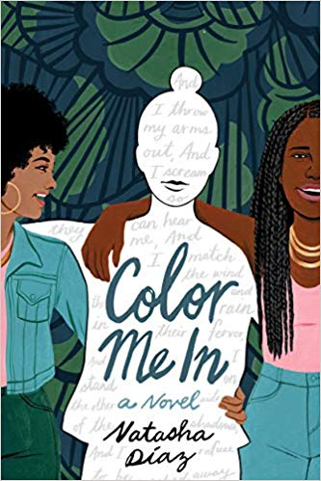 |  | Color Me In  By Natasha Diaz  2019, Delacorte Press
Black Like Me  (A Classic!!!)  By John Howard Griffin  Berkley; Anniversary edition (October 20, 2010) | 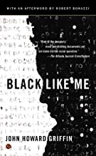 |  | Raising White Kids  By Jennifer Harvey  Abingdon Press; Reprint edition (February 5, 2019) |  | 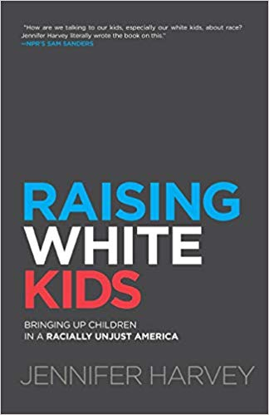
The New Jim Crow: Mass Incarceration in the Age of Colorblindness  By Michelle Alexander  The New Press; Anniversary edition (January 7, 2020) | 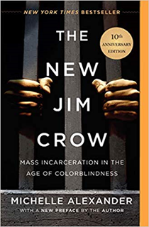 |  | Full Dissidence: Notes from an Uneven Playing Field  By Howard Bryant  2020, Beacon Press |  | 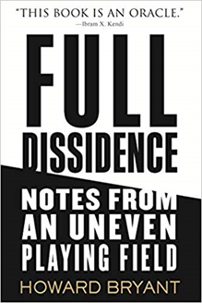
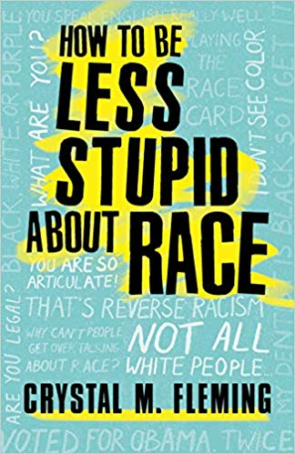 | How to Be Less Stupid About Race  By Crystal M. Fleming  Beacon Press; Reprint edition (August 20, 2019) |  |  |  | How Not to Get Shot: And Other Advice from White People  By D. L. Hughley  2018, William Morrow
Unequal City: Race, Schools, and Perceptions of Injustice  By Carla Shedd  2015, Russell Sage Foundation | 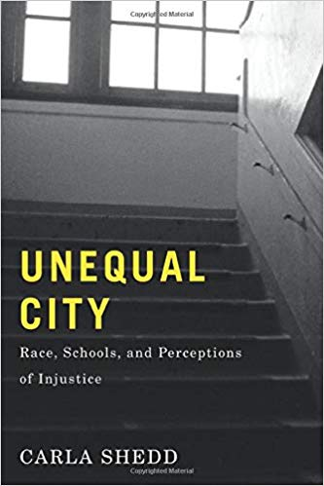
Movies you can view and submit a brief summary and reflection for credit:
13th  100 Years-One Woman’s Fight for Justice  Akeelah and the Bee  As Good as It Gets  Atlantics  Beasts of the Southern Wild  Belle  Bend it like Beckham  The Big Sick  Birthright: A War Story  The Borinqueneers  Boys Don’t Cry  Bullied: A Student, a School and a Case that Made History  Charlie & Sam  The Children’s March  The Chinese Exclusion Act  Chop Shop  Chi-Raq  CinemAbility: The Art of Inclusion  Clemency  The Color Purple  David and Lisa  A Day Without a Mexican  Dear White People  Django Unchained  Do the Right Thing  The Eagle Huntress  The Farewell |  | Fat Boy Chronicles  Fences  The Fits  The Florida Project  Fruitvale Station  Get Out  Hidden Figures  Hillbilly  The House We Live In  I Am Not Your Negro  I Carry You With Me  The Imitation Game  Jemima + Johnny  Jesus Camp  The Joy Luck Club  Knock Down the House  The Language You Cry In  The Laramie Project  Late Night  Lioness  Love & Basketball  Luce  Malcolm X  Medicine for Melancholy  Minari  Minty  Mississippi Burning  Moonlight  The Namesake |  | North Country  On Beauty  Parasite  Political Animals  The Pushouts  Queen of Katwe  RBG  Rape on the Night Shift  Real Women have Curves  Scar Tissue  Schindler's List  Silent Thunder  Sophie’s Choice  Tangerine  Time Flies When I’m Having Fun  A Time for Drunken Horses  Tomorrow Is Gonna Be Okay  Viva La Causa: The Story of César Chávez and a Great Movement for Social Justice  united skates  Us  Waves  Whale Rider  Yellow Rose  …or other films as approved by Dr. Bonjo or Libby
Podcasts you can listen to and submit a brief summary and reflection for credit:
LatinoUSA Podcast - An Acid Attack In Milwaukee |  |  | https://www.npr.org/2020/03/17/817491160/an-acid-attack-in-milwaukee
LatinoUSA Podcast - For Immigrant Communities, Coronavirus Is A Different Kind Of Threat |  |  | https://www.npr.org/2020/03/24/821015833/for-immigrant-communities-coronavirus-is-a-different-kind-of-threat
NPR Series Code Switch (any of their series) |  |  | https://www.npr.org/podcasts/510312/codeswitch
NPR Invisibilia Podcast:  - The Callout  - The Confrontation  - The Culture Inside |  |  | https://www.npr.org/podcasts/510307/invisibilia
TED Radio Hour Podcasts  - Anthropomorphic  - Beyond Tolerance  - Confronting Racism  - Confronting Stigma  - The Consequences Of Racism  - Gender, Power, and Fairness  - Why We Hate |  |  | https://www.npr.org/podcasts/510298/ted-radio-hour
TED Radio Hour 52 minute compilation - Erasing The Stigma |  |  | https://www.npr.org/2020/02/20/807794308/manoushs-favorites-gender-power-and-fairness
This American Life Podcast – Tell Me I’m Fat |  |  | https://www.thisamericanlife.org/589/tell-me-im-fat
An NPR Podcast Series White Lies |  |  | https://www.npr.org/podcasts/510343/white-lies
TED Radio Hour 52 minute compilation - Manoush's Favorites: Gender, Power, And Fairness |  |  | https://www.npr.org/2020/02/20/807794308/manoushs-favorites-gender-power-and-fairness

